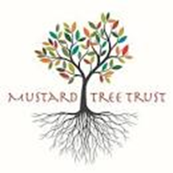
Message from the Chair
What a busy half term we have had, and, thanks to Kirstine and Deb's work, a fruitful harvest!
The Mustard Tree Trust continues to reach out to the children across Morpeth, Rothbury and the surrounding areas to share the stories of the Bible and to reveal what it is like to have a living relationship with God. As Trustees we work to ensure we move forward and find ways to support our workers in this: a significant area for growth is the involvement and support from our local churches.
We are non-ecumenical and not affiliated to one particular church - we work to touch the hearts of those from faith and non-faith families. If you, or someone from your church, would like to support our work there are many ways you could do this: for the price of a cup of coffee a month you could help to fund the work we do with a regular just giving donation (if you already do this consider friends and family who might be encouraged to do the same); we are seeking wider representation for our board of trustees; we are always looking for volunteers to get involved in different projects and, finally, but high on our list, we want supporters to help us raise the profile of the work we do amongst the church communities. If you can help in any way, please do contact Deb our administrator for a chat.
Heather Cape
Chair of Trustees
An Update from Kirstine

Thank you for all your support over the past school year. As we start a new one I have been reflecting on what I did and working out which activities are continuing
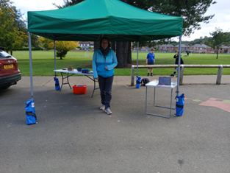
The Shelter
We started the years with a new project :“The Shelter”. This was designed to help Year 5
children who move up to Middle schools with their transition. As I was regularly in their first
school it was good for them to see a friendly familiar face in their middle school. I stood under my gazebo and chatted to them, make origami animals and asked them to think about how their week was going. I did this in both Dr Tomlinson’s, Rothbury and Chantry Middle school. It was well received and a positive experience for many – so it has been repeated! In fact this year I have had several good chats with the year 6’s who came last year. They have enjoyed coming and saying hello, and in one case I had a deeper chat with a child who was struggling with school.
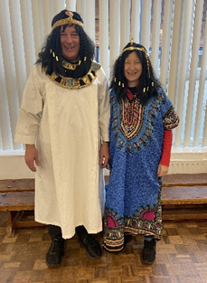
Open the Book
This storytelling project is held in every first school in Morpeth each month and in some schools it is twice a month. That means that every first school child, in year 1 and above hears a bible story every week. There is a team of about 8 of us who deliver this and we love it as much as the children!
If you would like to know more or be part of the team please contact Kirstine: kirstine.mtt@gmail.com


Christian Union at KEVI
Tuesday afternoons mean hot chocolates, complete with squirty cream and marshmallow, in the Sixth form café at King Edwards VI, high school. The group varies in size, depending on tests and time of year, but we have had a great, close knit group of teens, coming together to learn a bit more about Christianity and chat about things, usually over a game or 2. Many of them were in the school year who have just left, so this is a time of regrouping and regrowth as the younger ones move up
Extra events
I am often asked into school for other extra events, such as Harvest assemblies etc.
Last year I used “the Angel story”, complete with costume and wings, to tell the younger children about the Nativity story and what it means to Christians. I held similar events for the older children in first schools to explain Easter, using Resurrection Eggs as well as telling the story in Open the Book.

A Message from Debbie


As you can see, we continue to work with as many children as we can squeeze into the year. Lifepath continues to be a huge success, reaching hundreds of children each year from across Northumberland. We could not do any of this amazing work without the tremendous support we have from each and everyone of you. Thank you. Please continue your support and keep us in your prayers.
If you would like to support us, financially, as a volunteer or as a trustee please contact our administrator, Debbie - debbie.mustard.tree@gmail.com for more information.

