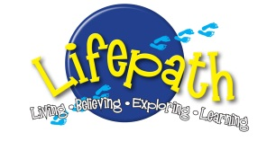
Lifepath Brinkburn 27 June- 1 July 2022
. . . . . . . . . . . . . . . . . . . . . . . . . . . . . . . . . . . . . . . . . . . . . . . . . . . . . . . .

Lifepath Brinkburn Needs You!

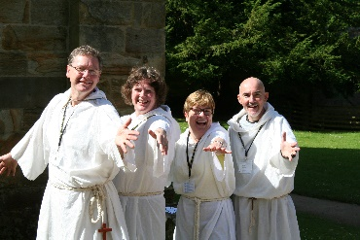
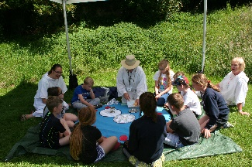
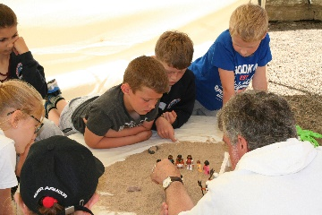
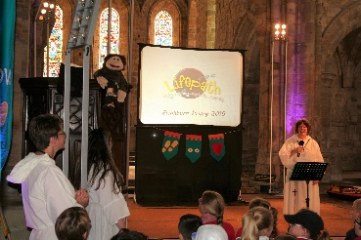

For the 10th time, The Mustard Tree Trust, Scripture Union, Schools and representatives from local churches are working in partnership to run an event for local primary school children called ‘Lifepath’ at Brinkburn Priory, near Rothbury.

This summer, ‘Lifepath Brinkburn’ is going to run from the 27 June – 1 July.

Bookings from schools are now coming in, and we look forward to welcoming hundreds of children (with teachers and helpers) for an exciting day of discovery and fun through drama, storytelling and creative arts workshops.

As in the previous years, they will be exploring the Christian faith by finding out about the life of St Oswald and how he Prayed to ensure that God was with him. At the same time, the children will be challenged to think about their own path through life, with an emphasis on their own spiritual development. We would like to have the prayer backing of as many local Christians as possible - or would you also consider volunteering and come along as an assistant workshop leader or ‘pilgrim guide’, for one or more of the days that week? Or maybe asking your church to make a financial donation?

All volunteers will need to come to a training session, undergo a DBS check, and complete the appropriate online volunteer leader form (which includes references) administered by Scripture Union.

So- if you’re interested in either taking part, receiving a prayer letter, or making a financial donation, please get in touch by email with either

Kirstine Davis (Mustard Tree Trust) kirstine.mtt@gmail.com
.

For more information, please look at www.mustardtreetrust.org

