Lifepath Brinkburn 24- 28 June 2024
. . . . . . . . . . . . . . . . . . . . . . . . . . . . . . . . . . . . . . . . .
Additional Information
The people who volunteer become either “Workshop helpers” or “Pilgrim Guides”. They have a big impact on the children as “Workshop helpers” explaining the same activity to lots of groups and “pilgrim guides” who are with the same group all day and guide them around the site. These guides are the ones who build the closest relationship with the children.
We need about 50 people each year to help in this and other supporting roles. In the past we have found that some people have come for only one day and others have come for the whole week!
Whatever role you are considering for this year’ event – we will consider your availability, personality and your preferences.
All volunteers will need to come to a training session, undergo a DBS check, and complete the appropriate online volunteer leader form (which includes references) administered by Scripture Union.

Training session for Lifepath volunteers will be on Monday 3rd June 2024 at St Mary’s Longframlington 7pm – 9pm. Please save the date and try to be there.

If you still have any questions please contact your Lifepath Champion. _______________________________________________________

Or Kirstine Davis via email: kirstine.mtt@gmail.com

And follow us on Facebook: https://www.facebook.com/LifepathBrinkburn

Lifepath Brinkburn 24 - 28 June 2024
. . . . . . . . . . . . . . . . . . . . . . . . . . . . . . . . . . . . . . . . .
Lifepath Brinkburn Needs You!
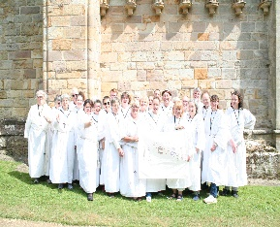
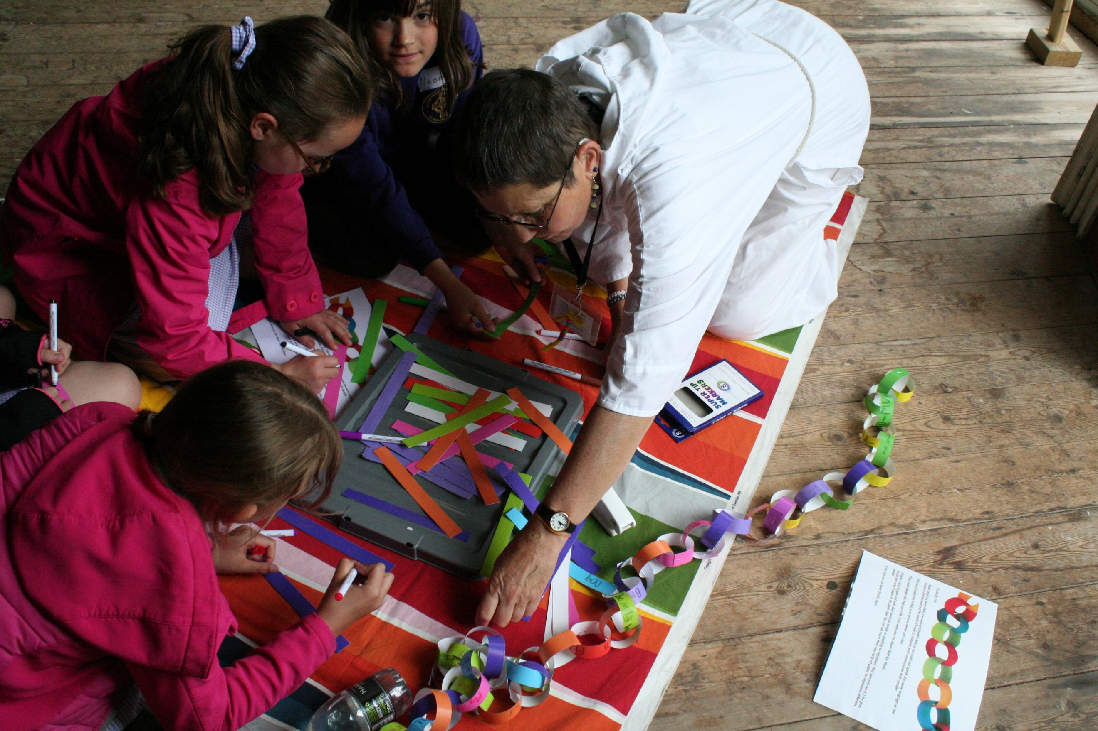
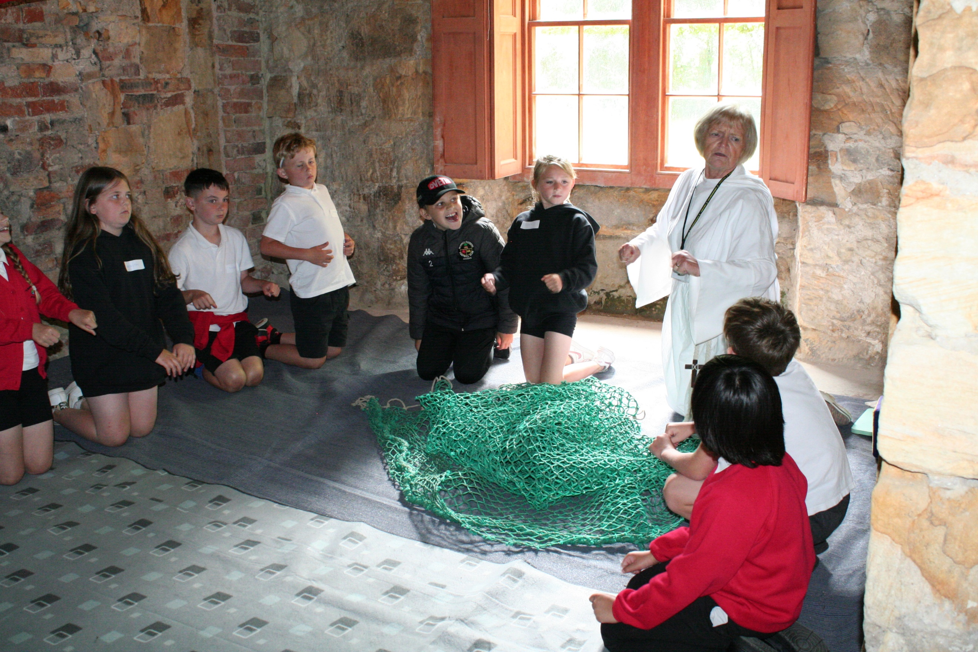
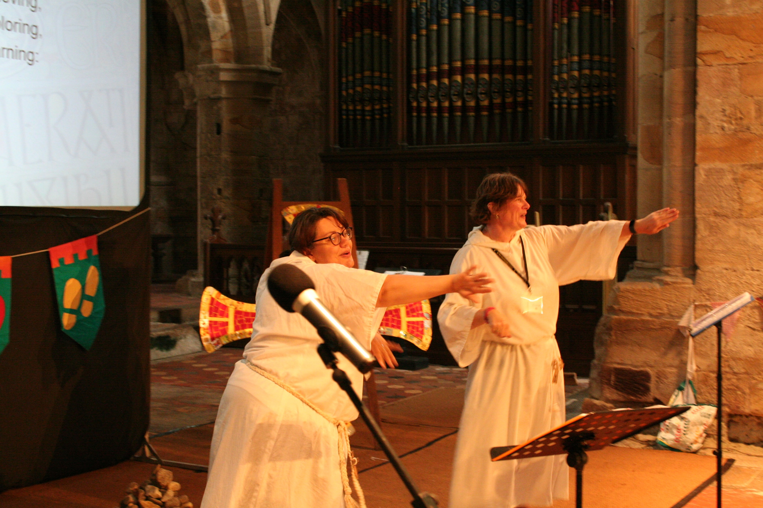

‘Lifepath’ at Brinkburn Priory, near Rothbury will be running for the 12th time this year. The Mustard Tree Trust, Scripture Union, United Reformed Church, reNEw NE, Schools and representatives from local churches are working in partnership to run this event for local primary school children. This summer, ‘Lifepath Brinkburn’ is going to run from the 24 - 28 June.

Bookings from schools are now coming in, and we look forward to welcoming hundreds of children (with teachers and helpers) for an exciting day of discovery and fun through drama, storytelling and creative arts workshops.

As in the previous years, they will be exploring the Christian faith by finding out about the life of a Northern saint. This year will be about St Cuthbert and how he connected with God through prayer, nature, the bible and other ways. At the same time, the children will be challenged to think about their own path through life, with an emphasis on their own spiritual development.

We would like to have the prayer backing of as many local Christians as possible - or would you also consider volunteering and come along as an ‘workshop helper’ or ‘pilgrim guide’? Continue reading to know more about the opportunities.

Would you like to volunteer?
A guide on How to Sign Up
We use the Scripture Union “Count me in” system, which collates all our information but is designed for residential events. You may find some of the questions irrelevant but do not feel obliged to give lots of detail.
1 – Go to the website www.scriptureunion.org.uk
2 – Register – or log in if you have used the system previously
3 – Find the word “Search” on the top left of the screen and click it. You can then type in “Lifepath Brinkburn”
4 – One of the items will be “Lifepath Brinkburn June 2020” – click on the blue title
5 – At the bottom of this screen, under a video of Kirstine, you will see a button labelled “Join the Lifepath Brinkburn Team”. Click this button and it will take you to the Volunteer portal
6 – At the bottom of the page is a blue button “Start your application form”. Click on this and fill in the questions as requested. You will be asked to choose an event, search for “Lifepath Brinkburn” and continue the form for “Full Team”
NOTES –
1 – There are several questions which aren’t relevant to Lifepath, after the Church information. Please just answer “No” until you reach the Reference section, (eg Catering and Worship group). You may need to repeat information, such as putting your mobile number in several boxes. If you need to, you can leave the page and come back to it later – if you have “Logged in”
2 – Please check you referees email addresses. We spend a lot of time chasing after people because their address is missing a tiny bit!
Can’t Volunteer…
But would like to be part of it? You Can…
Pray
We believe that prayer is a vital part of the support we need for Lifepath. If you sign up for our prayer letters you will receive four prayer letters a year (Feb, April, June, Sept), with plenty of information to guild your prayers for Lifepath, including areas for thanksgiving and particular needs. To sign up contact Kirstine Davis
Give Financially
Financial giving from churches and individuals is really important as we wish that all children may have access to Lifepath. The children’s schools do pay for the event but this covers only half the costs. If you contribute to the rest of the cost the money will go towards: Venue hire, Workshop expenses, toilets, coffee van, printing, admin expenses, hire tent etc. To give contact Kirstine Davis.
“Giving Handles”
a. A gift of just £16 would buy a copy of mini DOADs for a whole class of children
b. A gift of £5 would buy a Large, full version of “A Diary of a Disciple” for a school.
c. A gift of £12 would pay for the printing of the LP booklet for a whole class.
d. A gift of £9 would pay for the daily resources for the Jesus Journey workshop
e. A gift of £45 would pay for the resources for a whole day for the Craft workshop
f. A gift of £75 would pay for one of our team to go into your local school to introduce the day and lead an assembly. (Their milage, time and resources for this gift to every school)
g. A gift of £102 would pay for the hire of one toilet for the week

